Queue

Queues are a type of container adaptor, specifically designed to operate in a FIFO context (first-in first-out), where elements are inserted into one end of the container and extracted from the other.

FIFO is an acronym for first in, first out, a method for organizing and manipulating a data buffer, where the oldest (first) entry, or 'head' of the queue, is processed first. It is analogous to processing a queue with first-come, first-served (FCFS) behaviour: where the people leave the queue in the order in which they arrive.

Queues are implemented as containers adaptors, which are classes that use an encapsulated object of a specific container class as its underlying container, providing a specific set of member functions to access its elements. Elements are pushed into the "back" of the specific container and popped from its "front".
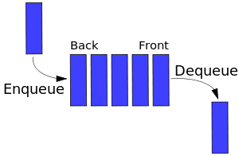

The underlying container may be one of the standard container class template or some other specifically designed container class. This underlying container shall support at least the following operations:

- empty – test whether container is empty;
- size – return size;
- front – access first element
- back – access last element
- push – insert element to the back;
- pop – remove front element;

Push numbers into queue and pop then in FIFO order:

#include <cstdio>
#include <queue>
using namespace std;

queue<int> q;

int main(void)
{
q.push(1); q.push(2); q.push(3); q.push(4); q.push(5);

printf("Queue contains %d elements\n",q.size());
while(!q.empty())
{
printf("Removed %d\n",q.front());
q.pop();
}

return 0;
}

